Instructions for use of the ‘Template Research Protocol’

The template research protocol has been prepared for investigators involved in medical scientific research with human subjects. This research must be submitted to an accredited medical research ethics committee (in Dutch: medisch ethische toetsingscommissie, METC) or the CCMO for approval, according the Medical Research Involving Human Subjects Act (in Dutch: Wet Medisch-wetenschappelijk Onderzoek met Mensen, WMO). In order to facilitate the process of submission, a standard research dossier has been developed which can be found on the website of the CCMO (www.ccmo.nl). One of the documents which has to be submitted for review is the research protocol, which should contain all necessary information for the reviewing medical research ethics committee to reach a weighed decision.

This template research protocol is meant to be a tool for investigators to write down their research proposal. If the research institute, organisation or company have their own format for research protocols, these standards can be used, provided that the essential information is included in the research protocol. The protocol may be written in English or in Dutch. This template consists of 14 chapters. Not all chapters have to be completed, depending on the type of research to be carried out. For sections not applicable please keep the session title, delete the example text and indicate ‘not applicable’.

It is also advised to contact the accredited METC which will review the protocol to collect information on local requirements.

The following texts are used in the template:
- <Italic text> = explanatory text
- straight text = example text
- [text] = make a choice
- balloons with remarks = explanatory note

Important: after completion, the research protocol can be printed without the balloons.
Word 2007: Microsoft Office-button – Print: in the print box choose print document (instead of document with formatting) (in Dutch: kies afdrukken en klik in het vak Afdrukken op Document (in plaats van Document met opmaak). See also the upper figure (in Dutch).
Alternatively, all comments (including revisions and annotations) can be deleted as follows: Microsoft Office-button – Prepare – Inspect document – only select ‘Comments, Revisions, Versions, and Annotations’ – Inspect – Remove all (in Dutch: Voorbereiden – Document controleren – alleen ‘Opmerkingen, revisies, …’ aanvinken – controleren – verwijderen).
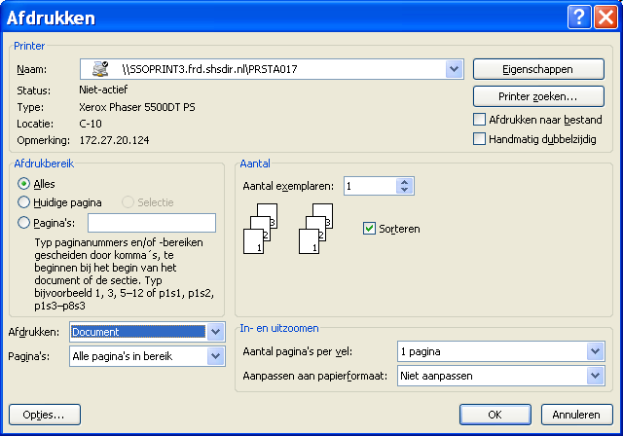

Older versions of Word: select Extra – Options – Track changes – Use balloons in print and web lay-out – Never (in Dutch: extra – opties – wijzigingen bijhouden – ballonnen gebruiken – nooit). See also the lower figure (in Dutch). 